**Tutorial 6**

**Implement the following programs in C++ language**

1. Create a class Employee which stores information about an employee (employee id, employee name and employee department). From this derive the class Salary which calculates the salary of an employee as follows:

Net_Pay = Basic_Pay + HRA + TA + DA – PF

HRA = 20% of Basic Pay

DA = 50% of Basic Pay

PF = 8% of Basic Pay

TA = 5% of Basic Pay

1. Create an interactive program which allows user to computer area or perimeter of any triangle. Create a class Triangle which contains a member function area() that calculates the area of any triangle. Derive classes named Isosceles and Equilateral which contains member function perimeter() that calculates the perimeter of any isosceles triangle and equilateral triangle respectively.
2. Create a class Account that stores account number and customer name. From this derive the classes Current and Savings to make them more specific to their requirements. Include necessary functions to achieve the following tasks:
   * Accept deposit to an account
   * Allow withdrawal from an account
   * Compute interest for a Savings account only at fixed 4% (use default argument for the same)
   * Compute maximum loan and payable interest that can be sanctioned for the Current account (maximum loan upto 200% of available balance at 10% fix per year)
3. An educational institution wishes to maintain a database of its employees. The database is divided into a number of classes whose hierarchical relationships are shown in Figure below. The figure also shows the minimum information required for each class. Specify all the classes and define methods to create the database and retrieve individual information as and when required.

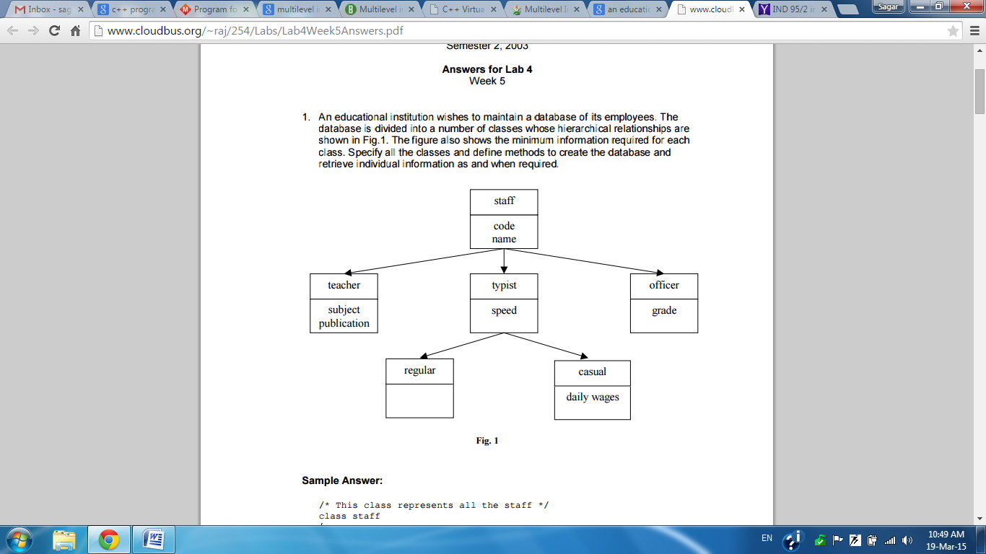

1. Create a class **Student** that stores student name and roll number. Class **Test** stores the information about marks obtained by the student in 5 different subjects and test number. **Sports** class contains details about achievements of students at 3 different levels and assigns score according to it to students (national level = 20 (score), state = 10 (score) and college = 5 (score)). **Result** class calculates the result of the students and stores the total marks and percentage obtained in the test.
2. Explain method overriding with a suitable example.
3. Explain the problem (ambiguity) in Multiple Inheritance. How this problem can be solved using Scope Resolution Operator. Demonstrate it with the help of a suitable program.
4. Explain Virtual Class with a suitable example.